Chapter 4, Solution 1.

i
30V

+
−
5 Ω
40 Ω
25 Ω
15 Ω
i_{o}

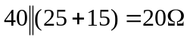, i = [30/(5+20)] = 1.2 and i_{o} = i20/40 = 600 mA.

Since the resistance remains the same we get can use linearity to find the new value of the voltage source = (30/0.6)5 = 250 V.

